LAB 13
(Total Marks 10)

Task 1: Create a program that utilizes interrupts to detect and display whether the keys (all alphabetic in your name) are pressed on the keyboard. The program should continue running until the Esc key is pressed, at which point it should exit the loop. (Hint int 16h)

org 0x100
jmp start
r : db 'R is pressed ..'
a : db 'A is pressed ..'
f : db 'F is pressed ..'
y : db 'Y is pressed ..'
R: db 'R'
A: db 'A'
F: db 'F'
Y: db 'Y'
location : dw 0x0703
subroutine:
mov bx, 0
mov ah, 0
int 0x16
cmp al, 'r'
je display_r
cmp al, 'a'
je display_a
cmp al, 'f'
je display_f
cmp al, 'y'
je display_y
ret
display_r:
mov ah, 0x13
mov al, 1
mov bh, 0 ; output on page 0
mov bl, 7 ; normal attrib
mov dx, [location] ;
mov cx, 15 ; length of string
push cs
pop es
mov bp, r
int 0x10
add bx , 1
add word[location],0x100
ret

display_a:
mov ah, 0x13
mov al, 1
mov bh, 0 ; output on page 0
mov bl, 7 ; normal attrib
mov dx, [location] ; row 9 column 3
mov cx, 15 ; length of string
push cs
pop es
mov bp, a
int 0x10
mov bx, 1
add word[location],0x100
ret

display_f:
mov ah, 0x13
mov al, 1
mov bh, 0 ; output on page 0
mov bl, 7 ; normal attrib
mov dx,[location] ; row 10 column 3
mov cx, 15 ; length of string
push cs
pop es
mov bp, f
int 0x10
mov bx, 1
add word[location],0x100
ret

display_y:
mov ah, 0x13
mov al, 1
mov bh, 0 ; output on page 0
mov bl, 7 ; normal attrib
mov dx,[location] ; row 11 column 3
mov cx, 15 ; length of string
push cs
pop es
mov bp, y
int 0x10
mov bx, 1
add word[location],0x100
ret

start:
jmp detect_key

detect_key:
call subroutine
cmp bx, 1 ; Check if any key in your name is pressed
je detect_key
mov ah, 0 ; Check if the Esc key is pressed
int 0x16
cmp al, 27
jne detect_key

; Exit the program
mov ax, 0x4C00
int 0x21
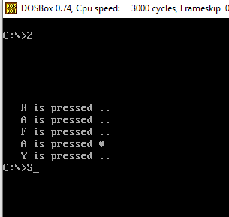

Task 2: Write a program that prompts the user to enter two integers within range 5 and then display their sum on the screen
org 0x100
jmp start
msg1 db 'Enter first num less than 5 :'
msg2 db 'Enter second num less than 5 :'
msg3 db 'Sum is '
temp : dw 0
location dw 0x0703
sum db 0

start:
mov ah, 0x13 ; First number input
mov al, 1
mov bh, 0
mov bl, 7
mov dx, [location]
mov cx, 29 ; Length of the message
push cs
pop es
mov bp, msg1
int 0x10
xor ax, ax ; Clear AX to store the input
int 0x16 ; BIOS interrupt for keyboard input
sub al, '0' ; Convert ASCII to integer
mov [temp], al
add word [location], 0x0400

mov ah, 0x13 ; Second number input
mov al, 1
mov bh, 0
mov bl, 7
mov dx, [location]
mov cx, 29 ; Length of the message
push cs
pop es
mov bp, msg2
int 0x10
xor ax, ax ; Clear AX to store the input
int 0x16 ; BIOS interrupt for keyboard input
sub al, '0' ; Convert ASCII to integer
add [temp] , al
add word [location], 0x0400

mov ah, 0x13 ; Display sum message
mov al, 1
mov bh, 0
mov bl, 7
mov dx, [location]
mov cx, 8 ; Length of the message
push cs
pop es
mov bp, msg3
int 0x10

add word[temp], '0' ; Convert sum to ASCII
mov ah, 0x0E
mov al, [temp]
int 0x10

mov ax, 0x4C00
int 0x21
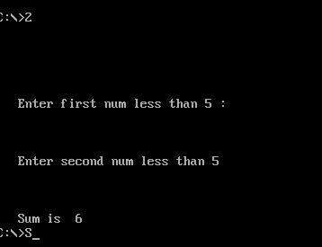
Best of luck

